JRSO Broadcast Radio Monitoring

Group members: Joseph James, Ramsey Lewis, Sebastien Ciobra & Owusu Okai
Support tutor: Dr Craig Gallen
Project Sponsor: Alan Beech – Commtronix Ltd
Github: https://github.com/com617-industrial-2025-1/com617-RadioSiteMonitoring-1

Table of Contents
Project Summary and Introduction 3
Group Contribution 4
Project Objectives 4
Requirements 6
SCOPE AND EXCLUSIONS 7
MONITORING AND EVALUATION 7
PROJECT ORGANISATION STRUCTURE 8
Project Deliverables 8
PROJECT MILESTONES & MANAGEMENT 9
Project Plan Management 9
IMPLEMENTATION 9
RESULTS 10
CONCLUSIONS AND RECOMMENDATION 10
REFERENCES 10
APPENDICES 11
Use of AI in the assessment 12
Ethical use of AI 12

Project Summary and Introduction

Group Contribution
We have use whatsapp group and discord to communicate with each other for project ideas , progress
Groups Members and their individual role
Sebastien
Joseph
Ramsey
Owusu

Project Objectives
The key tasks for your group are to:
- Improve the Grafana representation of the network (if possible)
- do additional SNMP radio monitoring for another site ( possibly a DAB transmitter MIB - to be supplied by Alan)
- add monitoring of the end to end DAB network using another management interface

You are faced with a complex challenge.
- set up the DAB Mux and DAB Mod software chain ( Alan may be able to help with this)
- get the stats from the modulator and multiplexer and use these to indicate any problems
- also syslog messages from both above.
- create an OpenNMS integration which finds problems in the network end to end.

Requirements

Tech Stack Requirements
Monitoring solution
- OpenNMS
- Postgresql
- Grafana
- Docker
- Remote raspberry pi’s (Minions)

SCOPE AND EXCLUSIONS

MONITORING AND EVALUATION

PROJECT ORGANISATION STRUCTURE

Project Deliverables

PROJECT MILESTONES & MANAGEMENT

Sprint 1

Sprint 2

Sprint 3

Week | Sprint Goal | Key Tasks | Team Member(s) | Tool(s) / Method Used | Output / Deliverable
1 | Project scoping & requirement allocation | - Review sponsor brief - Define monitoring objectives - Assign technical roles | All members | MS Teams, Trello, Brief documentation | Task allocation board Requirements backlog
2 | Research & architecture planning | - Research OpenNMS on Ubuntu - Review ODR DABMux & DABMod documentation - Design system architecture | Technical Lead + Research Lead | OpenNMS Docs, GitHub, Ubuntu docs | Architecture diagram Technical stack confirmation
3 | Environment deployment (Phase 1) | - Install Ubuntu server - Install OpenNMS & PostgreSQL - Validate system services | Technical Lead | Ubuntu CLI, OpenNMS installer, systemctl | Running OpenNMS instance Installation screenshots
4 | Device discovery & SNMP configuration | - Configure SNMP on test devices - Import required MIBs - Discover nodes in OpenNMS | SNMP Integration Lead | SNMP tools, OpenNMS UI | Node discovery screenshots SNMP polling validation
5 | Event logging & alarm configuration | - Configure syslog ingestion - Validate real-time events - Configure email notifications | Technical Lead | OpenNMS Events, Mail server | Alarm console screenshots Event validation logs
6 | DABMux statistics integration | - Configure DABMux management port - Extract JSON stats - Ingest into monitoring system | DAB Monitoring Lead | Ubuntu, JSON parser, OpenNMS | DABMux metric capture screenshots Stats validation
7 | DABMod monitoring integration | - Enable remote control interface - Extract performance metrics - Map alarms to OpenNMS | DAB Monitoring Lead | CLI tools, OpenNMS config | DABMod monitoring proof Alarm test results
8 | Business Service Monitoring & SLA setup | - Create business services - Map device alarms to service impact - Configure SLA thresholds | Technical Lead | OpenNMS BSM, SLA config | SLA breach simulation screenshots Service impact reports
9 | Performance monitoring & reporting | - Enable CPU, latency, availability graphs - Generate sample customer reports | Dashboard Lead | OpenNMS Performance tab | Performance graphs Availability report
10 | Grafana dashboard enhancement | - Integrate Grafana with PostgreSQL - Create customer-specific dashboards | Dashboard Lead | Grafana, PostgreSQL | Customer dashboard screenshots
11 | Final testing & evaluation | - Simulate service failures - Validate alarms & SLA calculation - Collect evaluation evidence | All members | Test environment, OpenNMS logs | Testing summary Validation screenshots
12 | Documentation & submission | - Finalise PID sections - Insert diagrams & evidence - AI declaration review - Final proofreading | Documentation Lead + All | Word, Reference Manager | Final PID (2000 words) Complete submission

IMPLEMENTATION
Using Linux to do the radio monitoring
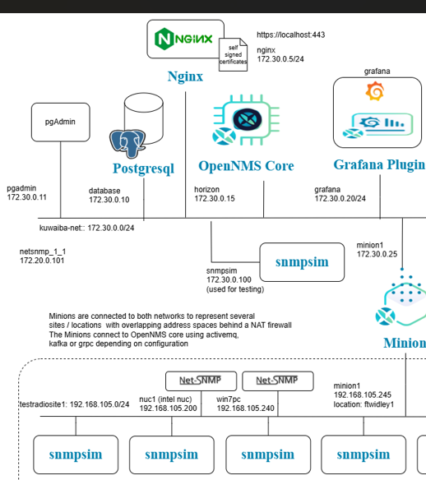
(gallenc, 2025)

Setting up the docker first

RESULTS

CONCLUSIONS AND RECOMMENDATION
The project demonstrates that OpenNMS is a technically viable and scalable solution for monitoring independent local radio transmitters operated by Commtronix.

REFERENCES

Dab mux - https://github.com/Opendigitalradio/ODR-DabMux
dab mod- https://github.com/Opendigitalradio/ODR-DabMod
hradio/odr-dabmod - https://hub.docker.com/r/hradio/odr-dabmod

https://github.com/gallenc/opennms-tutorials-1/tree/main/session6/kuwaiba-opennms-radio/kuwaiba-docker-compose-radio.

gallenc (2025). opennms-tutorials-1/session6/kuwaiba-opennms-radio/kuwaiba-docker-compose-radio/images/radioNetworkSimulation1.png at main · gallenc/opennms-tutorials-1. [online] GitHub. Available at: https://github.com/gallenc/opennms-tutorials-1/blob/main/session6/kuwaiba-opennms-radio/kuwaiba-docker-compose-radio/images/radioNetworkSimulation1.png

gallenc (2025). opennms-tutorials-1/session6/kuwaiba-opennms-radio/radio-mibs at main · gallenc/opennms-tutorials-1. [online] GitHub. Available at: https://github.com/gallenc/opennms-tutorials-1/tree/main/session6/kuwaiba-opennms-radio/radio-mibs
https://github.com/gallenc/opennms-tutorials-1/tree/main/session5
https://oneuptime.com/blog/post/2026-02-08-how-to-install-docker-on-linux-mint/view
https://hub.docker.com/_/ubuntu
https://git.launchpad.net/cloud-images/+oci/ubuntu-base/tree/oci/index.json?h=refs/tags/dist-jammy-amd64-20260322.1-991d8d05&id=991d8d055b7ec3f0d2e3704f95decfb991628ade

APPENDICES

Use of AI in the assessment

Ethical use of AI
AI platforms such as ChatGPT (OpenAI) and Claude (Anthropic) were used for technical guidance. These tools assisted in clarifying networking concepts, refining system design approaches, and improving the structure and articulation of technical explanations. They were not used to generate unverified technical configurations or replace practical implementation tasks. All configurations, monitoring setups, and system evaluations were independently performed, tested, and validated within the project environment.
Perplexity AI was used strictly for research purposes. It assisted in identifying relevant academic literature, technical documentation, and industry best practices related to radio network monitoring and management frameworks. All referenced materials were cross-verified using original sources before inclusion in this report.
In addition to AI tools, technical references were consulted from open-source repositories and documentation platforms, including GitHub resources such as Craig’s Tutorials and the Open Digital Radio project (https://github.com/opendigitalradio). These sources were used to understand practical implementation examples and industry-standard approaches. Any code snippets or configurations derived from these sources were reviewed, adapted where necessary, and appropriately acknowledged.

